Q1. From table salesman,create a view for those sales people who belong to the city of New York.

**create or replace view vu8 as select salesman_id,city,name,commision from salesman where city='New York';**

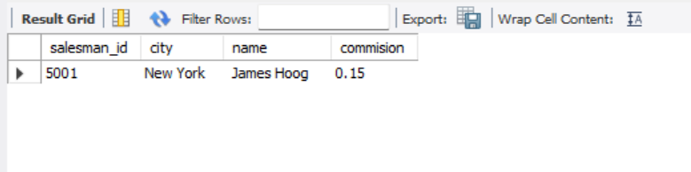

Q2. From Salesman table,create a view to display the salespeople whose commission is more than 0.13.

**create or replace view vu7 as select salesman_id,city,name,commision from salesman where commision>0.3;**

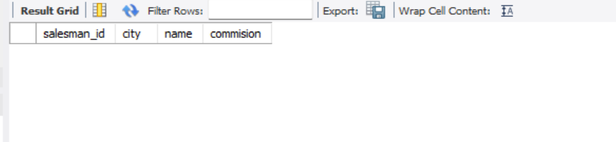

Q3. From table Customer,create a view that counts the number of customers in each grade.

**create or replace view vu9 as select grade, count(*) from customer group by grade;**

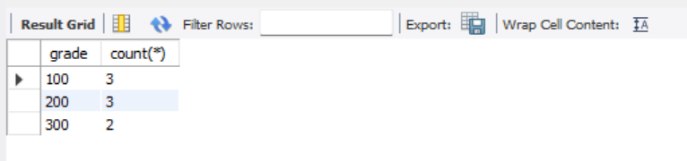

Q4. From table Orders,create a view to count the number of unique customers, compute the average and the total purchase amount of customer orders by each date.

**CREATE VIEW totalforday AS SELECT ord_date, COUNT(DISTINCT costomer_id), AVG(purch_amt), SUM(purch_amt) FROM orders GROUP BY ord_date;**

Q5. Create an index on 'custcity' column of the table 'customer'.

**CREATE INDEX idx_cust_name ON customer (cust_name);**

Q6.Create an index on combination of 'custcity' and 'cust_country' columns of the table 'customer'.

Q7.Apply the autoincrement clause on student table.

**CREATE TABLE class (student_id INT AUTO_INCREMENT PRIMARY KEY);**

Q8.From tables Salesman and Customer ,write a SQL query to find all salespeople and customers located in the city of London.(Use set operator).

**SELECT salesman_id AS name, 'Salesperson' AS type FROM Salesman WHERE city = 'London' UNION SELECT cust_name AS name, 'Customer' AS type**

**FROM CustomerWHERE city = 'London';**

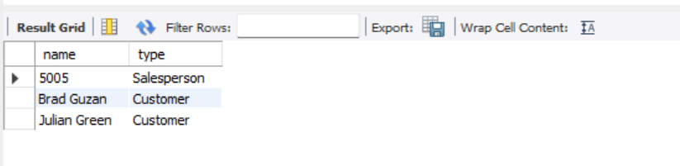

Q9.From tables Orders and Customer,write a SQL query to find all those salespeople and customers who are involved in the inventory management system. Return salesperson ID, customer ID.(Use set operator).

**SELECT salesman_id, customer_id FROM customer UNION (SELECT salesman_id, costomer_id FROM orders);**

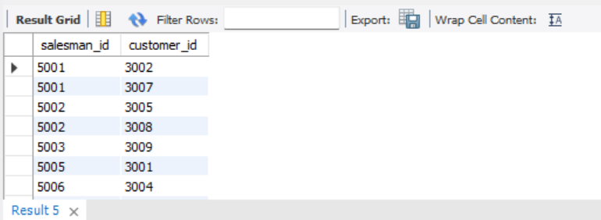

Q10. WAQ to display fourth highest salary using LIMIT clause.

**SELECT DISTINCT Salary FROM Employee ORDER BY Salary DESC LIMIT 1 OFFSET 3;**

